Waste and Biomass Valorization

https://doi.org/10.1007/s12649-020-01186-z

**ORIGINAL PAPER**



***Ipomoea batatas***

***Talinum paniculatum***

***Amaranthus defexus***

**Iraê Oliveira Moura1** **· Cláudio Carvalho Santana Jr1 · Yeseong Robert Familia Lourenço1 · Mariana Freitas Souza2 · Audrey Rouse Soares Tavares Silva3 · Silvio Santana Dolabella3 · Ana Mara de Oliveira e Silva4 · Tiago Branquinho Oliveira1 · Marcelo Cavalcante Duarte1 · Aurélia Santos Faraoni1**

Received: 13 February 2020 / Accepted: 21 July 2020

© Springer Nature B.V. 2020

**A**

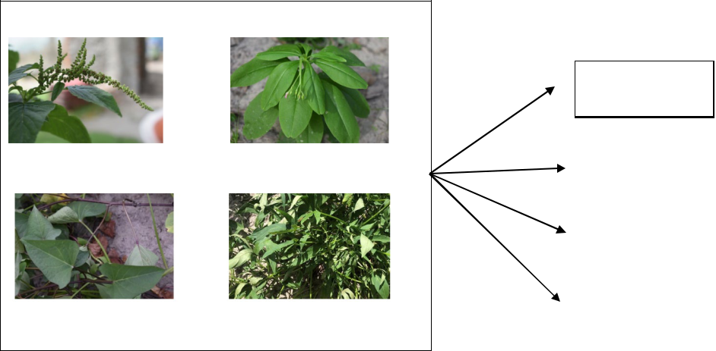

Physicochemical

characterization



|  |  |  |
| --- | --- | --- |
| *Amaranthus deflexus* L. | *Talinum paniculatum* (Jacq.) Gaertn. | Bioactive compounds |

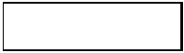

Antioxidant activity

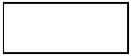

MTT assay

|  |  |  |
| --- | --- | --- |
| *Ipomoea batatas* (L.) Lam. | *Ipomoea batatas* (L.) Lam. | |
| (purple variety) | (white variety) | |
|  |  |  |

1 3



\ Waste and Biomass Valorization

**A**

**I**

]

′

]

**y** ]

1 3

Waste and Biomass Valorization\

′ ″

* ″

]

]

]

]

]

]

]

]

]

1 3

\ Waste and Biomass Valorization

**,** ]

]

] ]

] ]

]

]

1 3

Waste and Biomass Valorization\

]]

]

]

] ]

μ

μμ

μ

μ

]

μ

]

]μ

μμ

μ

μ

μ

μ

**I**

]

]

]µ

µ ×

µ

µ

]

1 3

\ Waste and Biomass Valorization

% scavenging = (Abscontrol −Abssample)∕Abscontrol × 100

]

µ

µ

] ×

µ

µ

]

µ µ

µµ

µ

µ

% Viability = (OD570 experimental wells∕D570 untreated control wells) × 100

µ

]

|  |  |
| --- | --- |
| %protection of oxidation = 100 − (Abssample × 100)∕Abscontrol | ′ |
|  | ] |

1 3

Waste and Biomass Valorization\

*H*�= −Σ(*PI*)(ln *PI*)

]

] ]

*J*�= *H*�∕ln(*S*)

′ ′

ó

]

]]

]

]

] ]

]

]

]

1 3

\ Waste and Biomass Valorization

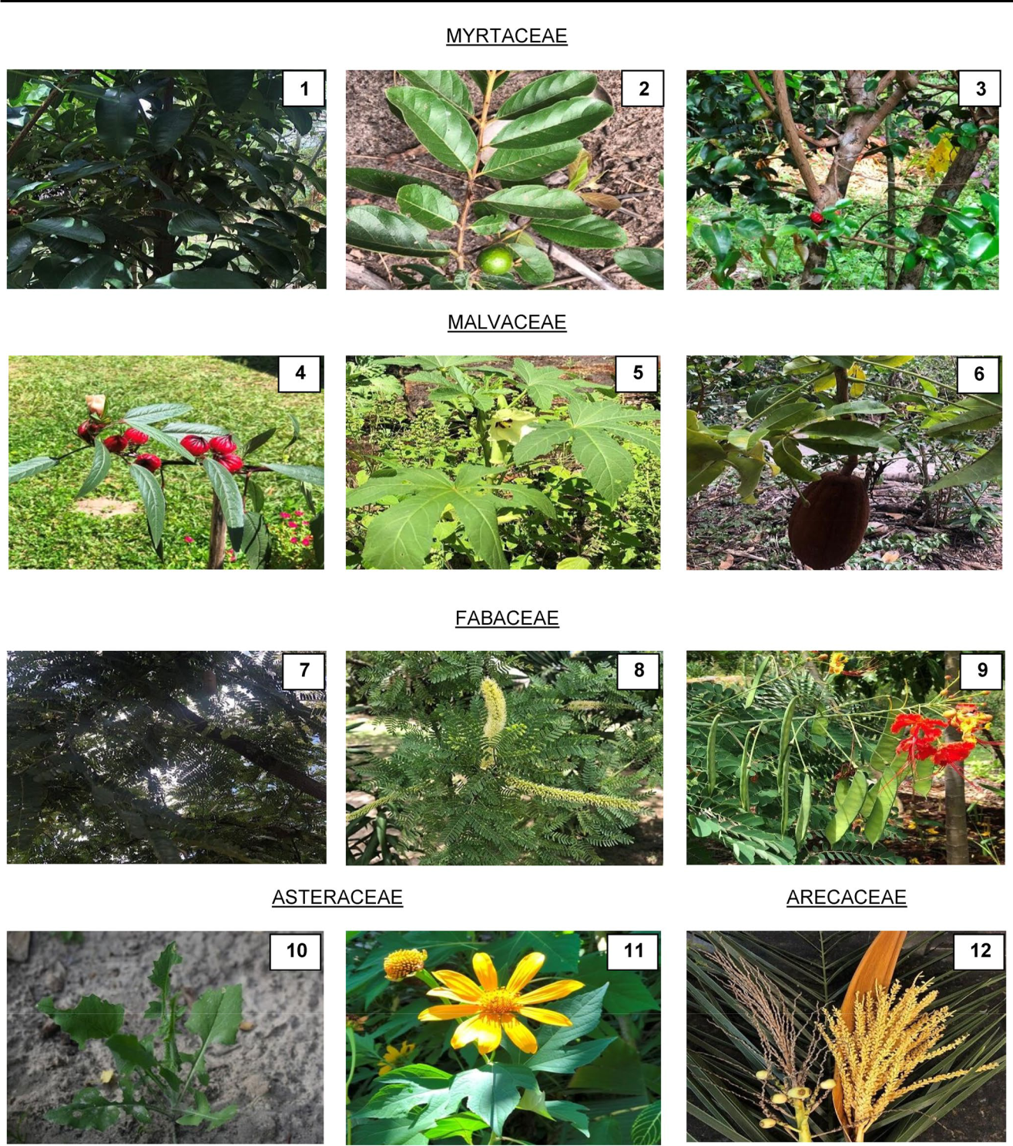

1 3

Waste and Biomass Valorization\

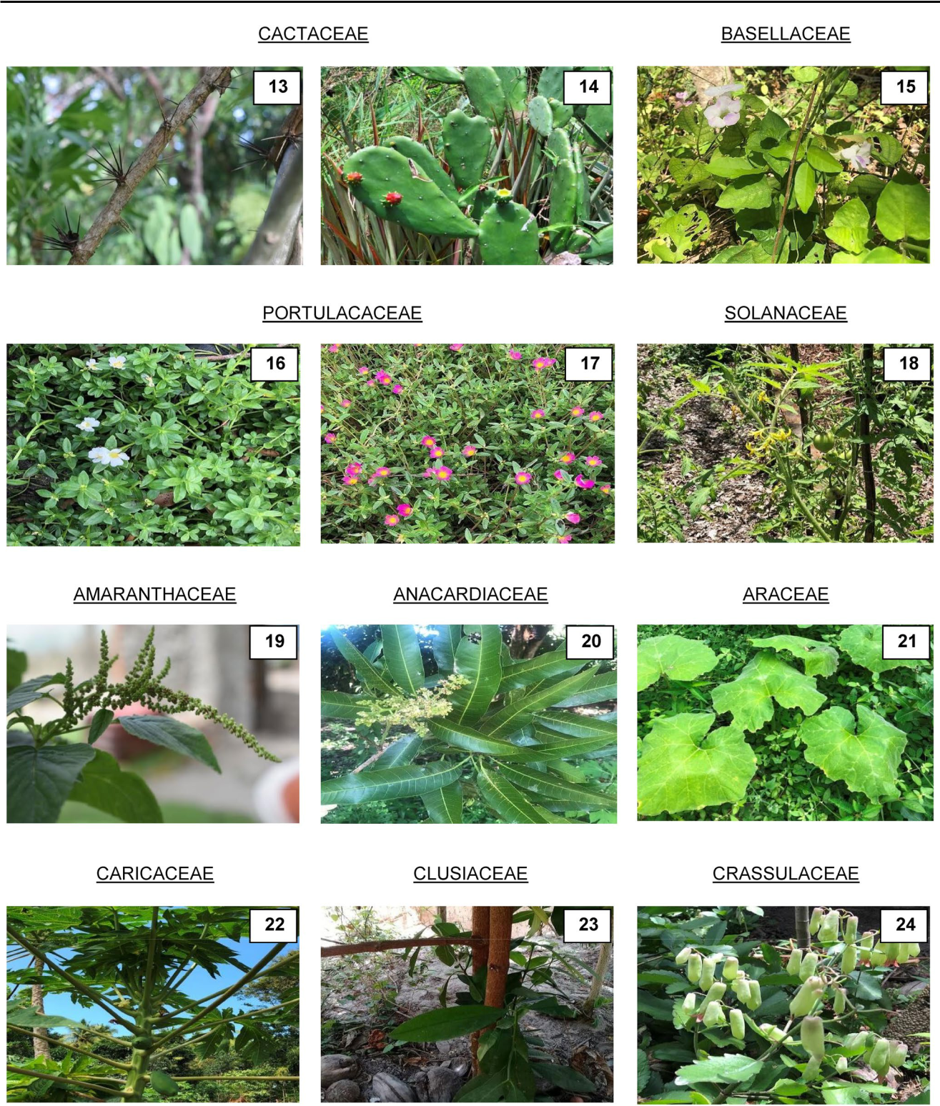

]

1 3

\ Waste and Biomass Valorization

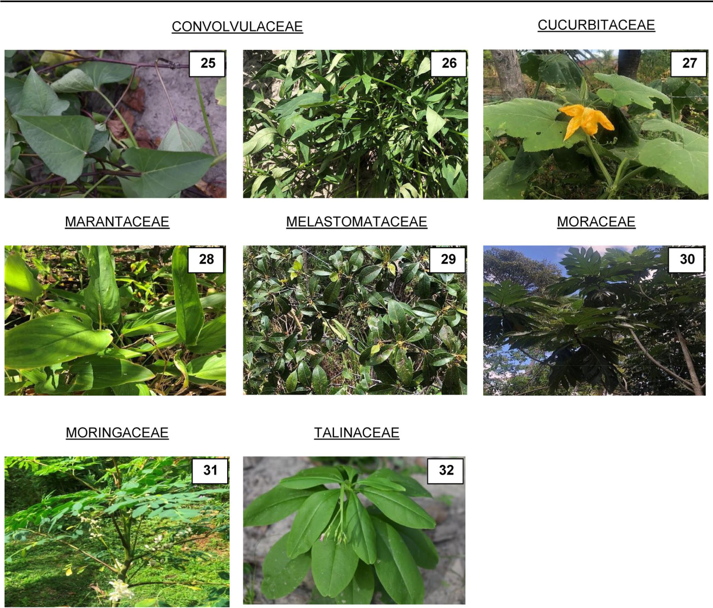

]

]]

]

]

]

1 3

Waste and Biomass Valorization\

]

′

] ]

′

′

]]

′ ]]

]

1 3

\ Waste and Biomass Valorization

1 3

Waste and Biomass Valorization\

]

1 3

\ Waste and Biomass Valorization

]

]

] ]

]

]

]

]

]

]

1 3

Waste and Biomass Valorization\

]

] **M**

]

]

]

]

]

]

]

]

]

**M**

]

]

]

]

]

µ

]

1 3

\ Waste and Biomass Valorization

µ

µ

µ

µ

] ]

|  |  |  |
| --- | --- | --- |
| ] | µ |  |
|  |  |
|  | µµ |  |
|  | ]µ |  |
|  | µµ |  |

1 3

Waste and Biomass Valorization\

|  |  |  |  |  |  |
| --- | --- | --- | --- | --- | --- |
|  |  |  |  | ] |  |
| µ | | µ |  | µ |  |
|  |  |  |
| µ | |  |  |  |  |
| µ] | |  |  |  |  |
| µµ | |  |  | µ |  |
| ] | |  |  |  |
| µ | |  |  | µ]µ |  |
| µµµ | |  |  | µµµ |  |
|  |  |  |  |  |
| µ] | |  |  | µ |  |
| µ | |  |  | µ |  |
| µµ | |  |  | µµµ |  |
|  |  | ]µ |  |
|  |  |  |  |  |
|  |  | ] | | µ |  |
|  |  |  |  | µµµ |  |
| ] | |  |  | **Z** |  |
|  |  |  |  | µ |  |
| µ | |  |  | µµ |  |
| µ | |  |  | µ |  |
| µ | |  |  | µ] |  |
| ] | |  |  | µ |  |
|  |  |  |  | ] |  |
|  |  |  |  | ] |  |
|  |  |  |  |  |  |
|  |  |  |  |  |  |
|  |  |  |  |  |  |
|  |  |  |  |  |  |
|  |  |  |  |  |  |
|  |  |  |  |  |  |

1 3

\ Waste and Biomass Valorization

µ

]

µ

µ

]

]

]

]

]

]

]

|  |  |  |
| --- | --- | --- |
|  | µ |  |
| µ | ] |  |
| µµ |  |  |
| ] | µ |  |
|  |  |
|  | µ |  |
| ] |  |  |

**I**

]

µ ]

µ

]µ µ

µ µ

µ ] µ µ

µ

]

1 3

Waste and Biomass Valorization\

**A** 100

|  |  |  |
| --- | --- | --- |
| (%) | 75 |  |
|  |  |

I C 5 0 = 1 9 6 .5 1 ± 2 .1 4 µ g /m L

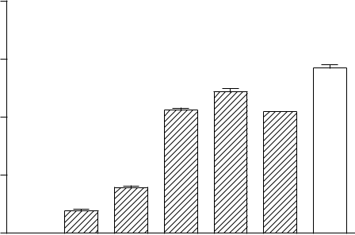

***

|  |  |  |  |
| --- | --- | --- | --- |
| **B** | 100 | I C 5 0 = 1 9 0 .8 9 ± 2 .3 1 µ g /m L |  |
|  |  |  |
| (%) | 75 | *** |  |
|  |  |

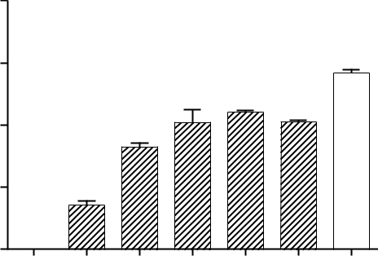

|  |  |  |
| --- | --- | --- |
| scavenging | 50 |  |
| radical- |  |  |
| DPPH | 25 |  |
| *** |  |
|  |  |
|  | 0 |  |

***

***

***

***

|  |  |  |  |  |  |
| --- | --- | --- | --- | --- | --- |
| -scavenging |  | *** | *** | *** |  |
| 50 |  |  |  |
| *** |  |  |  |
| radical |  |  |  |  |
|  |  |  |  |  |
| DPPH | 25 | ** |  |  |  |
|  |  |  |  |
|  |  |  |  |  |

|  |  |  |  |  |  |  |
| --- | --- | --- | --- | --- | --- | --- |
| System | 10 | 30 | 100 | 300 | 500 | 100 |

|  |  |  |
| --- | --- | --- |
| AEPP (µg/mL) | Trolox |  |
|  |  |
|  | (µg/ml) |  |

|  |  |  |  |  |
| --- | --- | --- | --- | --- |
| **C** | 100 |  | I C 5 0 = 5 1 6 .5 6 ± 1 .8 3 µ g /m L |  |
|  |  |  |
|  |  |  |

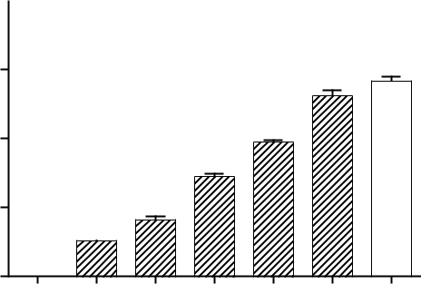

|  |  |  |  |  |  |  |  |  |
| --- | --- | --- | --- | --- | --- | --- | --- | --- |
| (%) | 75 |  |  |  |  | n s | *** |  |
| -scavenging |  |  |  | *** | *** |  |
| 50 |  |  |  |  |  |
|  |  |  |  |  |  |  |  |
| radical |  |  |  | *** |  |  |  |  |
| DPPH |  |  |  |  |  |  |  |
| 25 |  | *** |  |  |  |  |  |
|  |  |  |  |  |  |  |
|  |  | *** |  |  |  |  |  |  |
|  | 0 |  |  |  |  |  |  |  |
|  | System | 30 | 100 | 300 | 500 | 1000 | 100 |  |

AEMG (µg/mL) Trolox

(µg/mL)

|  |  |  |  |  |  |  |
| --- | --- | --- | --- | --- | --- | --- |
| 0 |  |  |  |  |  |  |
| System | 10 | 30 | 100 | 300 | 500 | 100 |
|  |  |  | AEWP (µg/mL) | |  | Trolox |
|  |  |  |  |  |  | (µg/mL) |

|  |  |  |  |  |
| --- | --- | --- | --- | --- |
| **D** | 100 |  | I C 5 0 = 1 3 9 .6 2 ± 1 .8 8 µ g /m L |  |
|  |  |  |

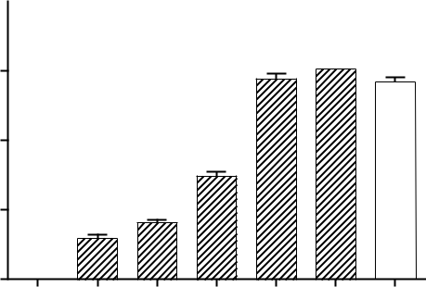

|  |  |  |  |  |  |  |  |  |
| --- | --- | --- | --- | --- | --- | --- | --- | --- |
| %) |  |  |  |  | n s | n s |  |  |
|  |  |  |  | *** |  |  |
| 75 |  |  |  | *** | *** |  |
| ( |  |  |  |  |
|  |  |  |  |  |
| scavenging | 50 |  |  |  |  |  |  |  |
| - |  |  |  |  |  |  |  |  |
| radical |  |  |  | *** |  |  |  |  |
| DPPH |  |  |  |  |  |  |  |
| 25 | *** | *** |  |  |  |  |  |
|  |  |  |  |  |  |
|  |  |  |  |  |  |  |  |
|  | 0 |  |  |  |  |  |  |  |
|  | System | 10 | 30 | 100 | 300 | 500 | 100 |  |

|  |  |
| --- | --- |
| AECA (µg/mL) | Trolox |
|  | (µg/mL) |

]

|  |  |  |
| --- | --- | --- |
|  | ] |  |
|  | µ |  |
|  | µ µ |  |
| ] | µ |  |
| µ |  |
|  | µ |  |
| µ | µ |  |
| µµ | µ |  |
|  | µ |  |

1 3

\

|  |  |  |  |  |
| --- | --- | --- | --- | --- |
| **A** |  | I C 5 0 = 7 6 .0 9 ± 1 .8 0 µ g /m L | |  |
| 100 |  | # # # | # # # |  |
|  |  |
| ) | *** | | *** |  |

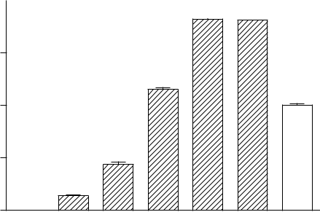

|  |  |  |  |  |  |  |  |  |
| --- | --- | --- | --- | --- | --- | --- | --- | --- |
| ic a l (% | 75 |  |  | # # # |  |  |  |  |
| d |  |  |  |  |  |  |  |
| ra |  |  |  | *** |  |  |  |  |
| T S |  |  |  |  |  |  |  |
| 50 |  |  |  |  |  | *** |  |
| B |  |  |  |  |  |  |  |
| o f A |  |  |  |  |  |  |  |  |
| n | 25 |  | *** |  |  |  |  |  |
| h ib itio |  |  |  |  |  |  |
|  | ** |  |  |  |  |  |  |
| In |  |  |  |  |  |  |  |
|  |  |  |  |  |  |  |  |
|  | 0 |  |  |  |  |  |  |  |
|  | S y s te m | 10 | 30 | 10 0 | 30 0 | 500 | 100 |  |

|  |  |
| --- | --- |
| A E P P ( µ g /m L ) | T ro lo x |
|  | ( µ g /m l) |

|  |  |  |  |  |
| --- | --- | --- | --- | --- |
| **C** |  |  | I C 5 0 = 4 8 1 .9 ± 1 .8 3 µ g /m L |  |
|  | 100 |  |  |  |
|  |  |  |  |

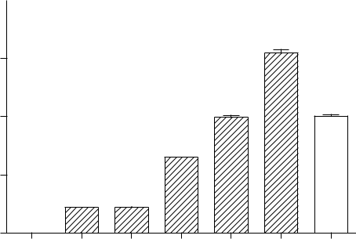

|  |
| --- |
| ) |

|  |  |  |  |  |  |  |  |  |
| --- | --- | --- | --- | --- | --- | --- | --- | --- |
| l (% |  |  |  |  |  | # # # |  |  |
|  |  |  |  |  | *** |  |  |
| ic a | 75 |  |  |  |  |  |  |
|  |  |  |  |  |  |  |
| ra d |  |  |  |  | n s |  |  |  |
| T S |  |  |  |  |  |  |  |
| 50 |  |  |  | *** |  | *** |  |
| B |  |  |  |  |  |  |  |
| o f A |  |  |  | *** |  |  |  |  |
| n | 25 |  |  |  |  |  |  |  |
| ib itio |  |  |  |  |  |  |  |
|  | *** | *** |  |  |  |  |  |
| In h |  |  |  |  |  |  |
|  |  |  |  |  |  |  |  |
|  | 0 |  |  |  |  |  |  |  |
|  | S y s te m | 30 | 100 | 300 | 500 | 1000 | 100 |  |
|  |  |  | A E M G ( µ g /m L ) | | |  | T r o lo x |  |
|  |  |  |  |  |  |  | ( µ g /m L ) |  |

Waste and Biomass Valorization

|  |  |  |  |  |
| --- | --- | --- | --- | --- |
| **B** |  | I C 5 0 = 5 2 .1 9 ± 1 .8 9 µ g /m L | |  |
| 100 |  | # # # | # # # |  |
|  |  |

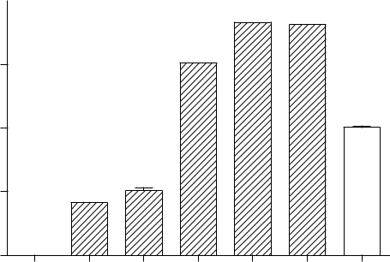

|  |  |  |  |  |  |  |  |  |
| --- | --- | --- | --- | --- | --- | --- | --- | --- |
| ) |  |  |  |  | *** | *** |  |  |
| (% |  |  |  | # # # |  |  |  |  |
| l |  |  |  | *** |  |  |  |  |
| ic a | 75 |  |  |  |  |  |  |
|  |  |  |  |  |  |  |
| r a d |  |  |  |  |  |  |  |  |
| T S | 50 |  |  |  |  |  | *** |  |
| B |  |  |  |  |  |  |  |
| o f A |  |  | *** |  |  |  |  |  |
| n |  |  |  |  |  |  |  |
| In h ib itio | 25 | *** |  |  |  |  |  |  |
|  |  |  |  |  |  |  |  |
|  | 0 |  |  |  |  |  |  |  |
|  | S y s te m | 10 | 30 | 100 | 300 | 500 | 100 |  |

A E W P ( µ g /m L ) T ro lo x

( µ g /m L )

**D**

I C 5 0 = 2 5 9 .1 5 ± 1 .8 1 µ g /m L

100

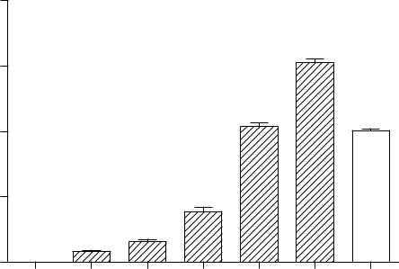

|  |
| --- |
| ) |

|  |  |  |  |  |  |  |  |  |
| --- | --- | --- | --- | --- | --- | --- | --- | --- |
| l (% |  |  |  |  |  | # # # |  |  |
|  |  |  |  |  | *** |  |  |
| ic a | 75 |  |  |  |  |  |  |
|  |  |  |  |  |  |  |
| ra d |  |  |  |  | n s |  |  |  |
| T S | 50 |  |  |  | *** |  | *** |  |
| B |  |  |  |  |  |  |  |
| o f A |  |  |  |  |  |  |  |  |
| n |  |  |  |  |  |  |  |  |
| h ib itio | 25 |  |  | *** |  |  |  |  |
|  |  | ** |  |  |  |  |  |
| In |  |  |  |  |  |  |  |  |
|  | 0 |  |  |  |  |  |  |  |
|  | S y s te m | 10 | 30 | 100 | 300 | 500 | 100 |  |

|  |  |
| --- | --- |
| A E C A ( µ g /m L ) | T ro lo x |
|  | ( µ g /m L ) |

µµµ

µ

µ

µ

µ µ

µ

]

µ

µµ

1 3

Waste and Biomass Valorization\

|  |  |  |  |  |
| --- | --- | --- | --- | --- |
| **A** | 100 |  | I C 5 0 = 1 4 6 .3 6 ± 1 .8 3 µ g /m L |  |
|  |  |  |  |

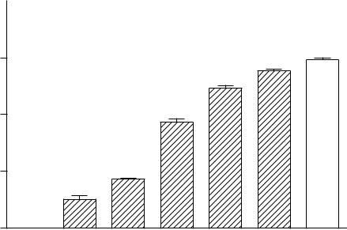

|  |  |  |  |  |  |  |  |  |
| --- | --- | --- | --- | --- | --- | --- | --- | --- |
| ( % ) |  |  |  |  |  |  | *** |  |
| n | 75 |  |  |  |  |  |  |
| a tio |  |  |  |  | *** |  |  |
|  |  |  |  |  |  |  |
|  |  |  |  | *** |  |  |  |
| f o x id | 50 |  |  | *** |  |  |  |  |
| o |  |  |  |  |  |  |  |  |
| ct io n | 25 |  | *** |  |  |  |  |  |
| r o te |  |  |  |  |  |  |
|  | *** |  |  |  |  |  |  |
| P |  |  |  |  |  |  |  |  |
|  | 0 |  |  |  |  |  |  |  |
|  | S y s te m | 10 | 30 | 10 0 | 300 | 500 | 100 |  |

|  |  |
| --- | --- |
| A E P P (µ g /m L ) | T ro lo x |
|  | ( µ g /m l) |

|  |  |  |  |  |
| --- | --- | --- | --- | --- |
| **B** | 100 |  | I C 5 0 = 8 2 .9 2 ± 1 .8 1 µ g /m L |  |
| ) |  |  |  |
|  |  |  |  |

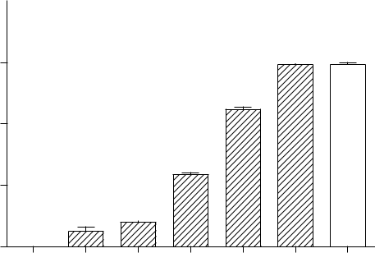

|  |  |  |  |  |  |  |  |  |
| --- | --- | --- | --- | --- | --- | --- | --- | --- |
| % |  |  |  |  |  | n s |  |  |
| n ( | 75 |  |  |  |  | *** | *** |  |
| id a tio |  |  |  |  |  |  |  |
|  |  |  |  | *** |  |  |  |
| f o x |  |  |  |  |  |  |  |
| 50 |  |  |  |  |  |  |  |
| o |  |  |  |  |  |  |  |  |
| tio n | 25 |  |  | *** |  |  |  |  |
| c |  |  |  |  |  |  |  |
| o te |  |  | *** |  |  |  |  |  |
| P r |  | ** |  |  |  |  |  |
|  |  |  |  |  |  |  |
|  | 0 |  |  |  |  |  |  |  |
|  | S y s te m | 3 | 10 | 30 | 100 | 300 | 100 |  |

A E W P ( µ g /m L ) T ro lo x

( µ g /m L )

|  |  |  |  |  |
| --- | --- | --- | --- | --- |
| **C** | 100 |  | I C 5 0 = 3 6 5 .4 6 ± 1 .9 3 µ g /m L |  |
|  |  |  |
|  |  |  |

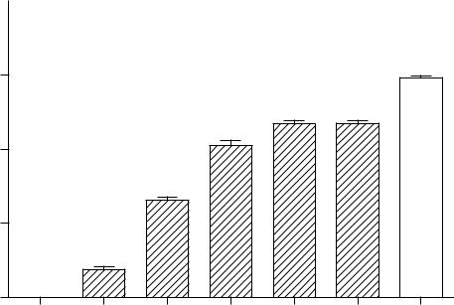

|  |  |  |  |  |  |  |  |  |
| --- | --- | --- | --- | --- | --- | --- | --- | --- |
| n ( % ) | 75 |  |  |  |  |  | *** |  |
| a tio |  |  |  |  |  |  |  |
|  |  |  |  | *** | *** |  |  |
| x id |  |  |  | *** |  |  |
|  |  |  |  |  |  |  |
| f o | 50 |  |  |  |  |  |  |  |
| o |  |  | *** |  |  |  |  |  |
| n |  |  |  |  |  |  |  |
| c tio | 25 |  |  |  |  |  |  |  |
| r o te |  |  |  |  |  |  |  |
|  | *** |  |  |  |  |  |  |
| P |  |  |  |  |  |  |  |
|  |  |  |  |  |  |  |  |
|  | 0 |  |  |  |  |  |  |  |
|  | S y s te m | 30 | 100 | 300 | 500 | 1000 | 100 |  |

**D**

|  |
| --- |
| P r o te c t io n o f o x id a tio n ( % ) |

IC 50

100

75

50

25

|  |  |  |
| --- | --- | --- |
| 0 |  |  |
| S y s te m | 10 | 30 |

= 5 7 1 .7 9 ± 1 .9 8 µ g /m L

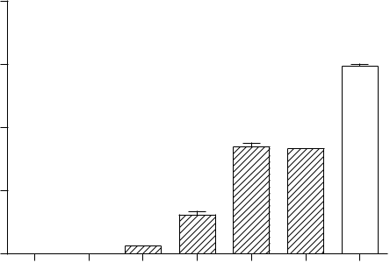

|  |  |  |  |
| --- | --- | --- | --- |
|  |  |  | *** |
|  | *** | *** |  |
| *** |  |  |  |
| 100 | 300 | 500 | 100 |

A E M G ( µ g /m L ) T r o lo x

( µ g /m L )

|  |  |
| --- | --- |
| A E C A ( µ g /m L ) | T ro lo x |
|  | ( µ g /m L ) |

µ

]

µ

µµ

µ

µ

µ

µ

1 3

\ Waste and Biomass Valorization

**A**

|  |
| --- |
| Cell viability (% ) |

|  |  |  |  |  |
| --- | --- | --- | --- | --- |
| 120 |  |  | **B** |  |
| 100 |  |  |  |  |
| 80 |  |  | ) |  |
| 40 |  |  | (% |  |
|  |  | Cellviability |  |
| 60 |  |  |  |  |
| 20 |  |  |  |  |
| 0 |  |  |  |  |
| 0 | 50 | 100 | 1000 |  |
|  |  | A E P P (µ g /m L ) |  |  |

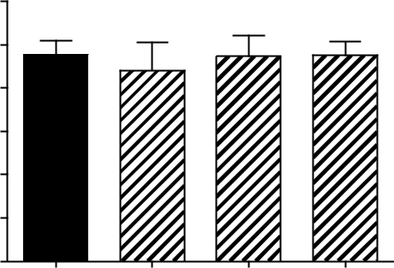

|  |  |  |  |  |
| --- | --- | --- | --- | --- |
| 120 |  |  |  |  |
| 100 |  |  |  |  |
| 80 |  |  | * * * |  |
|  |  |  |  |
| 60 |  |  |  |  |
| 40 |  |  |  |  |
| 20 |  |  |  |  |
| 0 |  |  |  |  |
| 0 | 50 | 100 | 1000 |  |
|  |  | A E W P (µ g /m L ) |  |  |

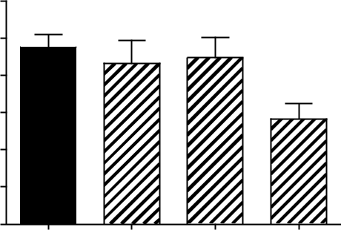

**C**

|  |
| --- |
| Cell viability (% ) |

|  |  |  |  |  |
| --- | --- | --- | --- | --- |
| 120 |  |  | **D** |  |
| 100 |  |  |  |  |
| 80 |  |  | ) |  |
| 40 |  |  | (% |  |
|  |  | Cellviability |  |
| 60 |  |  |  |  |
| 20 |  |  |  |  |
| 0 |  |  |  |  |
| 0 | 50 | 100 | 1000 |  |
|  |  | A E M G (µ g /m L ) |  |  |

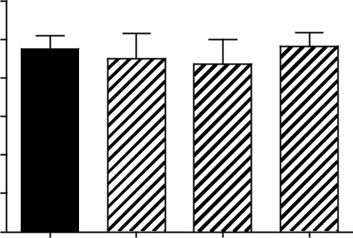

|  |  |  |  |
| --- | --- | --- | --- |
| 120 |  |  |  |
| 100 |  |  |  |
| 80 |  |  |  |
| 60 |  |  |  |
| 40 |  |  |  |
| 20 |  |  |  |
| 0 |  |  |  |
| 0 | 50 | 100 | 1000 |
|  |  | A E C A (µ g /m L ) |  |

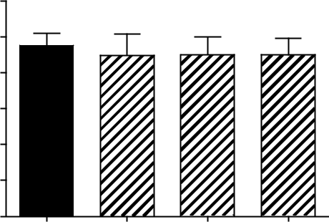

µ

1 3

Waste and Biomass Valorization\

**22**

[_](http://www.abcsem.com.br/docs/manual_hortalicas_web.pdf)

**4**

**17**

**179**

ó

**58**

**78**

**25**

**148**

**19**

**64**

**28**

**26**

**48**

**50**

**5**

**23**

1 3

\ Waste and Biomass Valorization

**7**

**30**

**43**

**1**

**273**

**42**

**4**

**10** **103**

**14**

**33**

**15**

**58**

**4**

**31**

Á

**25** **47**

1 3

Waste and Biomass Valorization\

**208**

|  |  |
| --- | --- |
| **66** |  |
| **30** | **8** |
| **81** | **20** |

*Z*

**11**

**57**

**’**

**16**

**Af**

**Iraê Oliveira Moura1** **· Cláudio Carvalho Santana Jr1 · Yeseong Robert Familia Lourenço1 · Mariana Freitas Souza2 · Audrey Rouse Soares Tavares Silva3 · Silvio Santana Dolabella3 · Ana Mara de Oliveira e Silva4 · Tiago Branquinho Oliveira1 · Marcelo Cavalcante Duarte1 · Aurélia Santos Faraoni1**

**\***

|  |  |  |
| --- | --- | --- |
|  | ó |  |
| ó | ó |  |
|  |  |
| ó |  |  |

1 3